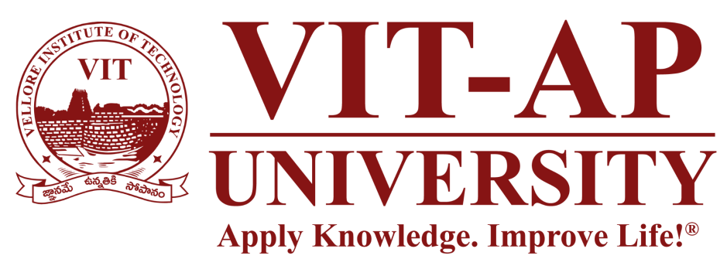

Zeroth Review

Project Title:-
SkyWrite In The Wind Using Python And OpenCv

Course: Summer Internship Project (22 Batch MTCSE & MTSE) Presented by: 1) G. Thulasidhar Reddy [Reg. No. 22MIC7099]
2) V. Jaya Chandra [Reg. No. 22MIC7215]
3) K. Vishwesh Aryan [Reg. No. 22MIC7109]
Project Guide:Prof: A. Padma

Abstract

Imagine drawing on your screen without ever touching it. That's the core idea behind our project. We're building an application that watches your finger's movement through a webcam and turns that motion into digital brushstrokes on a virtual canvas.

The whole system is built with Python, using the power of OpenCV for camera work and Google's Mediapipe library for incredibly accurate hand tracking. It's a fresh and intuitive way to interact with a computer, moving beyond the keyboard and mouse to something more natural.
- Keywords: Gesture Recognition, Air Writing, Computer Vision, OpenCV, Mediapipe.

Introduction & Motivation

- So, why are we doing this? We've all gotten used to typing on keyboards and clicking a mouse,

but as technology like augmented and virtual reality becomes more popular, we need better,

more natural ways to interact with our digital world.

- While some apps can recognize basic gestures, writing in the air is a bigger challenge. It's not

enough to just see a hand; you have to find the fingertip, track it smoothly, and trace its path.

Our project tackles this head-on. We want to build an "Air Canvas" that feels intuitive, allowing

anyone to just raise their finger and start creating.

Project Objectives

- First we'll build a working system that lets you draw on a screen in real-time just by moving your hand.
- We're going to use a standard, off-the-shelf webcam, so the system is accessible to anyone without needing special hardware.
- A key part of the project is implementing high-accuracy hand and fingertip detection using the Mediapipe library. This will give us the precise coordinates we need for drawing.
- We'll use OpenCV to handle all the visual processing—capturing the video, drawing the user's path, and displaying the final canvas.
- Finally, we'll build a simple user interface so you can easily switch between colors or clear the screen.

System Requirements

We're keeping the requirements fairly simple to ensure the project can run on most modern laptops.

- Hardware:
  - A computer with at least an i3 processor.

  - A minimum of 4GB of RAM.

  - About 40GB of available disk space.

  - And of course, a webcam.

- Software:
  - The project is built entirely in Python.

  - We're using a few essential open-source libraries:

    - OpenCV: This is our engine for all the computer vision tasks.

    - Mediapipe: This is what we'll use for the powerful hand-tracking features.

    - NumPy: This helps us handle all the numerical data, like the coordinates of the drawing points, efficiently.

- Methodology

how will it all work together?
- Start the Camera: First, the application activates the webcam and starts reading the video
feed, frame by frame.
- Find the Hand: Each frame is sent to the Mediapipe library, which looks for a hand. If it finds
one, it identifies 21 specific points (or "landmarks") on it, like the wrist, knuckles, and
fingertips.

- Read the Gesture: Our code then checks the position of these landmarks to figure out what
the user is doing. If just the index finger is up, we know they want to draw. If the index and
middle fingers are up, they're in "selection mode" and can point at buttons without leaving a
mark.

- Trace and Draw: When in drawing mode, the application records the coordinates of the index
fingertip in every frame. It then connects these dots on the separate paint window, creating a
smooth line that follows the user's motion in the air.

THANKYOU.

